<?php

    $db = mysqli_connect("localhost", "root", "", "image_upload");

    $msg = "";

    if (isset($_POST['upload'])) {

    $image = $_FILES['image']['name'];

    $image_text = mysqli_real_escape_string($db, $_POST['image_text']);

    $target = "images/".basename($image);

    $sql = "INSERT INTO images (image, image_text) VALUES ('$image', '$image_text')";

    mysqli_query($db, $sql);

    if (move_uploaded_file($_FILES['image']['tmp_name'], $target)) {

        $msg = "Image uploaded successfully";

    }else{

        $msg = "Failed to upload image";

    }

}

  $result = mysqli_query($db, "SELECT * FROM images");

?>

<!DOCTYPE html>

<html lang="en">

<head>

    <meta charset="UTF-8">

    <meta http-equiv="X-UA-Compatible" content="IE=edge">

    <meta name="viewport" content="width=device-width, initial-scale=1.0">

    <link rel="stylesheet" href="css/style.css" type="text/css">

    <title>Image Upload</title>

</head>

<body>

    <div id="content">

        <?php

    while ($row = mysqli_fetch_array($result)) {

        echo "<div id='img_div'>";

        echo "<img src='images/".$row['image']."' >";

        echo "<p>".$row['image_text']."</p>";

        echo "</div>";

    }

        ?>

        <form method="POST" action="index.php" enctype="multipart/form-data">

            <input type="hidden" name="size" value="1000000">

            <div>

                <label>Select Your Image</label><br/>

                <input type="file" name="image" id="file">

            </div>

            <div>

                <label>Enter Your message</label><br/>

                <textarea id="text" cols="40" rows="4" name="image_text"

                    placeholder="Say something about this image..."></textarea>

            </div>

            <div>

                <button class="submit"type="submit" name="upload">Submit</button>

            </div>

        </form>

    </div>

</body>

</html>

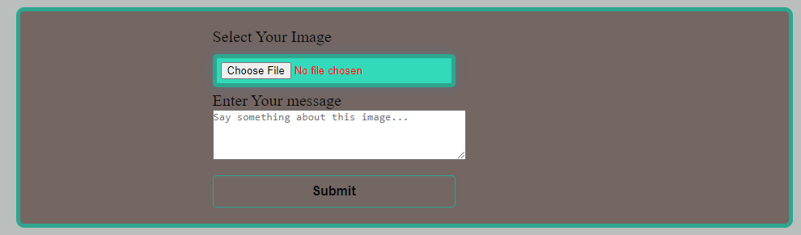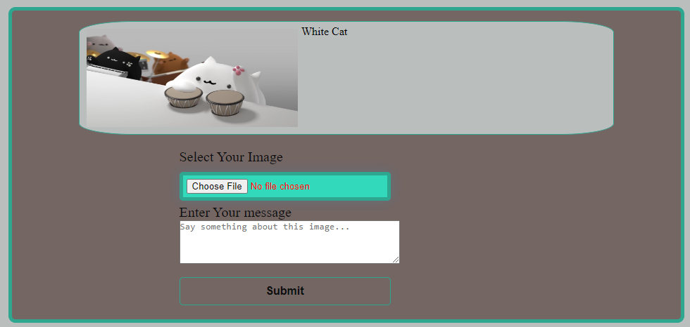

Câu 2:

Index.php

<?php

include_once 'dbconnect.php';

// fetch files

$db_handle = new dbconnect();

$sql = "select filename from tbl_files";

$result = $db_handle->execute($sql);

?>

<!DOCTYPE html>

<html>

<head>

    <title>Upload View & Download file in PHP and MySQL</title>

    <meta content="width=device-width, initial-scale=1.0" name="viewport" >

    <link rel="stylesheet" href="css/bootstrap.css" type="text/css" />

</head>

<body>

<br/>

<div class="container">

    <div class="row">

        <div class="col-xs-8 col-xs-offset-2 well">

        <form action="upload.php" method="post" enctype="multipart/form-data">

            <legend>Select File to Upload:</legend>

            <div class="form-group">

                <input type="file" name="file1" />

            </div>

            <div class="form-group">

                <input type="submit" name="submit" value="Upload" class="btn btn-info"/>

            </div>

            <?php if(isset($_GET['st'])) { ?>

                <div class="alert alert-danger text-center">

                <?php if ($_GET['st'] == 'success') {

                        echo "File Uploaded Successfully!";

                    }

                    else if ($_GET['st'] == 'error')

                    {

                        echo 'Invalid File Extension!';

                    }

                    else{

                        echo 'Invalid File!';

                    }?>

                </div>

            <?php } ?>

        </form>

        </div>

    </div>

    <div class="row">

        <div class="col-xs-8 col-xs-offset-2">

            <table class="table table-striped table-hover">

                <thead>

                    <tr>

                        <th>#</th>

                        <th>File Name</th>

                        <th>View</th>

                        <th>Download</th>

                    </tr>

                </thead>

                <tbody>

                <?php

                $i = 1;

                while($row = mysqli_fetch_array($result)) { ?>

                <tr>

                    <td><?php echo $i++; ?></td>

                    <td><?php echo $row['filename']; ?></td>

                    <td><a href="uploads/<?php echo $row['filename']; ?>" target="_blank">View</a></td>

                    <td><a href="uploads/<?php echo $row['filename']; ?>" download>Download</td>

                </tr>

                <?php } ?>

                </tbody>

            </table>

        </div>

    </div>

</div>

</body>

</html>

Upload.php

<?php

require_once("dbconnect.php");

$db_handle = new dbconnect();

//check if form is submitted

if (isset($_POST['submit']))

{

    if(isset($_FILES['file1'])){

    $filename = $_FILES['file1']['name'];

    if($_FILES['file1']['error']>0){

        header("Location: index.php?st=fileerror");

    }

    else{

        //upload file

        if($filename != '')

        {

            $ext = pathinfo($filename, PATHINFO_EXTENSION);

            $allowed = ['pdf', 'txt', 'doc', 'docx', 'png', 'jpg', 'jpeg',  'gif'];

            //check if file type is valid

            if (in_array($ext, $allowed))

            {

            // get last record id

            $sql = 'select max(id) as id from tbl_files';

            $result = $db_handle->execute($sql);

            if ($db_handle->numRows($sql)> 0)

            {

            $row = mysqli_fetch_array($result);

            $filename = ($row['id']+1) . '-' . $filename;

            }

            else

            $filename = '1' . '-' . $filename;

            //set target directory

            $path = 'uploads/';

            $created = @date('Y-m-d H:i:s');

            move_uploaded_file($_FILES['file1']['tmp_name'],($path . $filename));

            // insert file details into database

            $sql = "INSERT INTO tbl_files(filename, created) VALUES('$filename', '$created')";

            $db_handle->execute($sql);

            header("Location: index.php?st=success");

            }

            else

            {

                header("Location: index.php?st=error");

            }

        }

        else

            header("Location: index.php");

        }

    }

}

?>

dbconnect.php

<?php

//connect mysql database

class dbconnect{

    private $host = "127.0.0.1";

    private $user = "root";

    private $password = "";

    private $database = "demo";

    private $conn;

    function __construct() {

        $this->conn = $this->connectDB();

        if(!empty($this->conn)) {

            $this->selectDB();

        }

    }

    function connectDB() {

        $conn = mysqli_connect($this->host,$this->user,$this->password,$this->database);

        return $conn;

    }

    function numRows($query) {

        $result  = mysqli_query($this->conn, $query);

        $rowcount = mysqli_num_rows($result);

        return $rowcount;

    }

    function selectDB() {

        mysqli_select_db($this->conn, $this->database);

    }

    function execute($query) {

        $result  = mysqli_query($this->conn, $query);

        return $result;

    }

}

?>

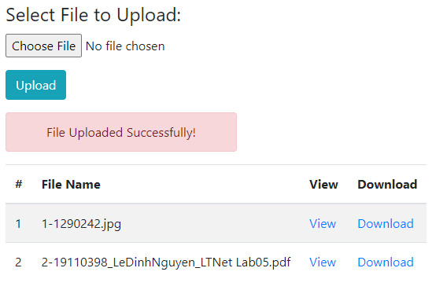

Nhấn View



Download file

